# 10. Arrays Lab

**Tasks**

Download the starting files from Moodle for this lab.

In this zipped file you will find most of the HTML code. You only need to add the **function name to call** in the onclick event for each button.

While I will demonstrate each task, it is important you ask any questions if you do not understand the code. Remember CA2 will be based on JavaScript.

**Ensure that you have the console open** when you are testing your code. This way if an error occurs, the console will help/show you.

The following screen is created using HTML. We will click each button and call a JavaScript function. The JavaScript functions will access values in the form and dynamically update the page.

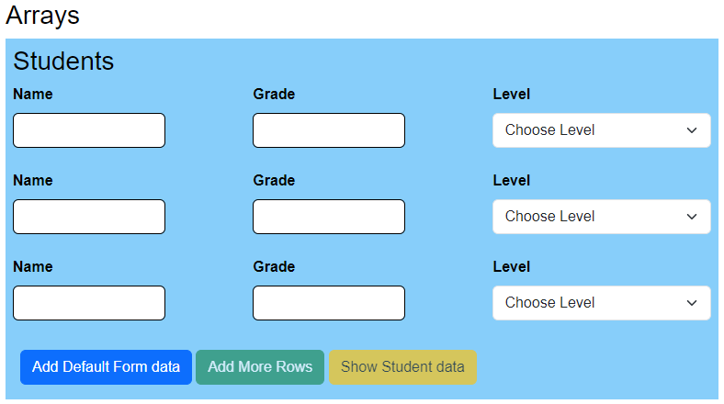

1. **Update the HTML file.**

Update the HTML page with the function name you are calling for the **onclick** event.

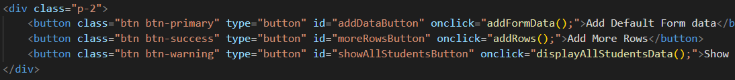

1. **Update the script file.**

It is important to read the comments in the solution code to help you understand the purpose of each line of code. If you do not understand, then please ask.

1. **Create 3 global array variables and disable some buttons**

* Create global arrays for the student name, grade, and level.
* For each global array use the method getElementsByClassName() to get all the textbox values. For example:

let studNames = document.getElementsByClassName("fullName");

* Disable two buttons:
* moreRowsButtontons
* showAllStudentsButton

1. **Add the function addFormData()**

When the user clicks the “Add Default Form data” button, we want to update the form with the values from the local arrays. This is just dummy data to populate the form with. We also enable the buttons that were disabled.

* Create 3 local array variables – one for the student name, grade, and level. For example:

let names = ["Ben", "Katherine", "Dylan"];

let grades = ["C", "A", "B"];

let levels = ["2", "1", "2"];

* Create a loop to assign each local array value above to the corresponding global array we declared at the start.

Remember the global arrays have Live HtmlCollection returned by the method getElementsByClassName(). Therefore, each array contains a reference to the Html element on the page. So, this line of code:

console.log( studNames[0] );

outputs: **<input type="text" class="fullName">**

In contrast to the value **Ben** outputtedfrom this line of code:

console.log( studNames[0].value );

* Therefore, in the body of your loop and for each array use the format:

studNames[i].value = names[i];

* Enable the two buttons that you disabled.
* The resulting output of your code should be:

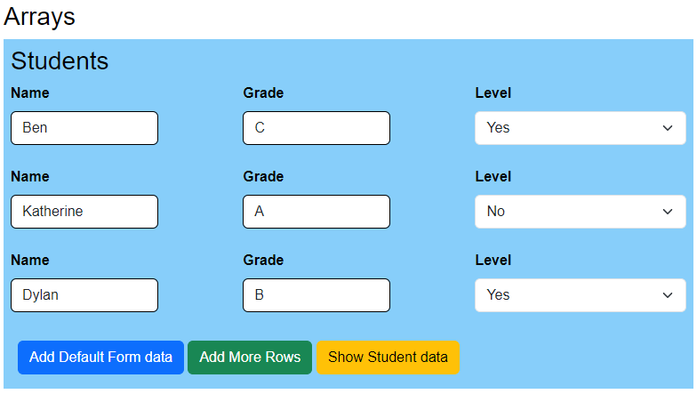

1. **Add the function addRows()**

* This function will add an extra row to the form as shown below:

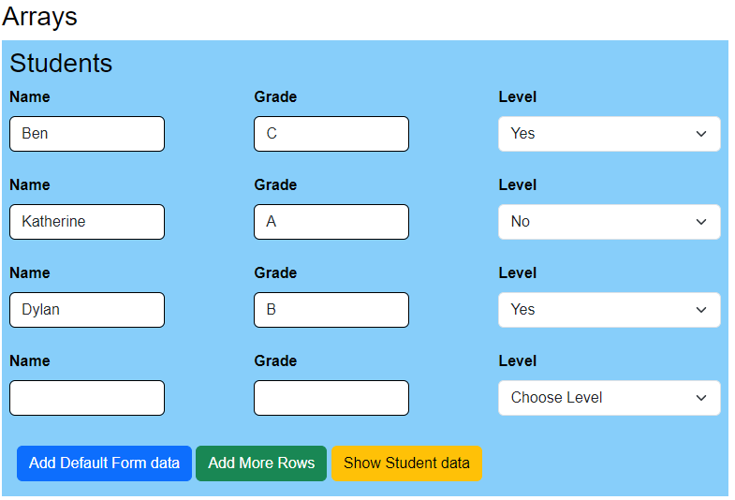

* We have done something similar in the previous labs. However, this one is slightly more complicated.
* Therefore, I am going to add a screenshot of the solution. Review the code and explanation for each line of code in the screenshot. You can also view this code in the completed Zip file.

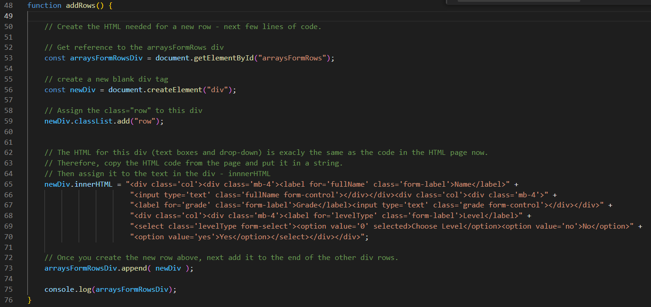

1. **Add the function displayAllStudentsData()**

This function will create a table from all the student data in the form. For example:

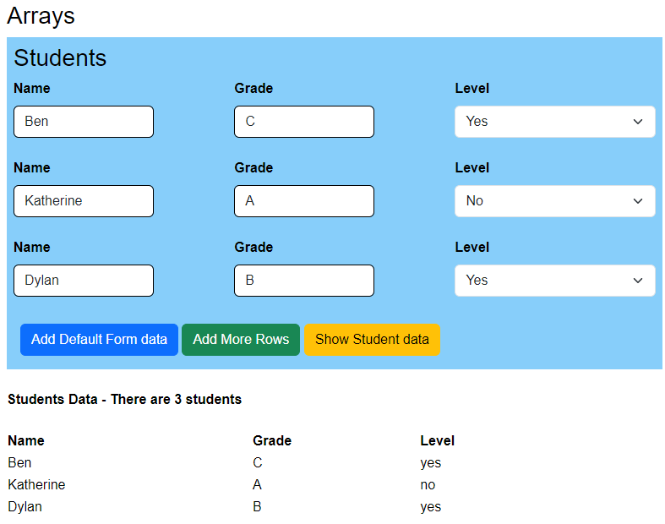

* The table is outputted in the **allStudentsData** div.
* Get a reference to this div using:

document.getElementById("allStudentsData");

* Then create a string of the HTML code and the student values. Here is the start of the code:

let studStr = "<br><b>Students Data - There are " + studNames.length + " students</b><br><br>";

studStr += "<table><tr><th>Name</th><th>Grade</th><th>Level</th></tr>";

* Next, create a for loop where you append the table row, column, and student values:

for( let i=0; i < studNames.length; i++ ) {

        studStr += "<tr><td>" + studNames[i].value + "</td>" +

                    "<td>" + studGrades[i].value + "</td>" +

                    "<td>" + studLevels[i].value + "</td></tr>";

    }

    studStr +=  "</table>"

Finally, add the string to the div:

allStudentDataDiv.innerHTML = studStr;

1. **Add the function printArrays()**

Create a function to print all the 3 global arrays to the console.